# Porting Numbers

Lineblocs currently supports port-in requests in various funded rate centres.

For a complete list of assisted regions, please see [Supported Rate Centers](https://lineblocs.com/resources/other-topics/supported-rate-centers).

## Port-In Request Requirements

If you are trying to port in a number to lineblocs, please keep in mind the following requirements:

1. The number you are trying port should not have been disconnected by the provider
2. No dispute should be open with the porting number
3. Porting number should not be scheduled for disconnection
4. The porting number cannot have a contract
5. The number you port must be available in a rate centre we support

## Start Port Request

To start a Port-In request, please log in to the Lineblocs portal then access the port request page at [Create Port Request](https://app.lineblocs.com/#/dashboard/dids/ports/create)

On the port request page, you will need to provide us with the following info:

1. Your First and Last Name
2. Local Address
3. Letter of Authorization (LOA) - a letter of authorization from the number owner
4. Customer Service Record (CSR) - a customer service record
5. Recent invoice from your provider - an invoice dated no longer than 90 days

## Submitting Port-In Request

To submit your port-in request, please fill in the fields on the [Create Port Request](https://app.lineblocs.com/#/dashboard/dids/ports/create), and then click the "Save" button.

## Port-In Review Stages

Once you have submitted your port-in request, you will be sent updates whenever the port-in request status changes.

The statuses your port-in request will go through can include the following:

1. Pending Review

This is when we have received your port in request but have not confirmed on our end yet.

1. Received

Port in request was received, and lineblocs has confirmed it will attempt the port-in request.

1. Submitted to Provider

The port request was sent to your current carrier

1. Confirmed

Your port-in has been confirmed, and an ETA has been provided.

1. Completed

Your port-in is now completed

You will be notified via email whenever the port-in request status and when an ETA for the port is established.

You can also track the status of your Port-In request by accessing the [Create Port Request](https://app.lineblocs.com/#/dashboard/dids/ports/create) and checking the Status column in the port numbers list.

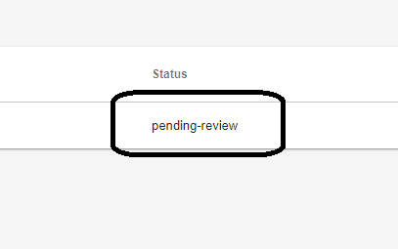

## Editing Port Request

You may be required to edit your port-in request depending on whether more personal information is required.

To update your port-in request please go to the [Port Requests Page](https://app.lineblocs.com/#/dashboard/dids/ports)

then click the IMG_257 icon on the ported number.

## Next Steps

For more info on managing numbers or billing related to numbers, be sure to see the articles below:

[Managing Numbers](https://lineblocs.com/resources/managing-numbers/manage-numbers)

[Monthly Invoices](https://lineblocs.com/resources/billing-and-pricing/monthly-invoices)